YCAP Board of Directors  Alexandra Mitretodis, President  Fasken Martineau DuMoulin LLP, Vancouver  Christina Doria, VP Education and Events  Baker & McKenzie LLP, Toronto  Vasuda Sinha, VP Technology  Freshfields Bruckhaus Deringer, Paris  Jessica Crow, Secretary  Vinson & Elkins LLP, London  Joanne Luu, Treasurer  Burnet, Duckworth & Palmer LLP, Calgary  Eric Bédard  Woods, Montreal  Michelle Chai  Stewart McKelvey LLP, Halifax  Frédéric Côté  BCF LLP, Montreal  Martin Doe  Permanent Court of Arbitration, The Hague  Alison FitzGerald  Norton Rose Fulbright LLP, Ottawa  Lauren Harper  Osler, Hoskin & Harcourt LLP, Toronto  Mark Klaver  Global Affairs Canada, Ottawa  Hugh Meighen  Borden Ladner Gervais, Toronto  Margaret Clare Ryan  Shearman & Sterling, London  Carlos Sayo  Davies Ward Phillips & Vineberg LLP, Toronto  YCAP Advisory Board  Lev Alexeev  Pomerleau, Montreal  Cristina Birks  Borden Ladner Gervais LLP, Montreal  Joseph Chedrawe  Vinson & Elkins, Dubai  Tina Cicchetti  Cicchetti Arbitration Law Corp., Vancouver  Mark A. Luz  Global Affairs Canada, Ottawa  Sarah McEachern  Borden Ladner Gervais, Vancouver  Eric Morgan  Osler, Hoskin & Harcourt LLP, Toronto  Romeo Rojas  Bennett Jones LLP, Calgary  John Siweic  Perley-Robertson, Ottawa  YCAP Sponsors  Borden Ladner Gervais LLP  Burnet, Duckworth & Palmer LLP  Davies Ward Phillips & Vineberg LLP  Fasken Martineau DuMoulin LLP  Freshfields Bruckhaus Deringer LLP  FTI Consulting, Inc.  Miller Thomson LLP  Norton Rose Fulbright LLP  Osler, Hoskin & Harcourt LLP  White & Case LLP  Woods | YCAP 2019 Spring SYMPOSIUM  in conjunction with ICDR Y&I and CFA 40  Topic: Approaches to Witness Evidence in International Arbitration  Tuesday, 2 April 2019  8:00 am CEST | Registration & Breakfast  9:00 - 10:30 am CEST | Panel Presentation  Shearman & Sterling  7 rue Jacques Bingen  Paris, France  SPEAKERS:  Philippe Boisvert, Associate - White & Case (Paris)  Eléonore Caroit, Associate - Lalive (Geneva)  Margaret Clare Ryan, Associate - Shearman & Sterling (London)  Sarah Ganz, Counsel - Wilmer Hale (London)  __________________________________________  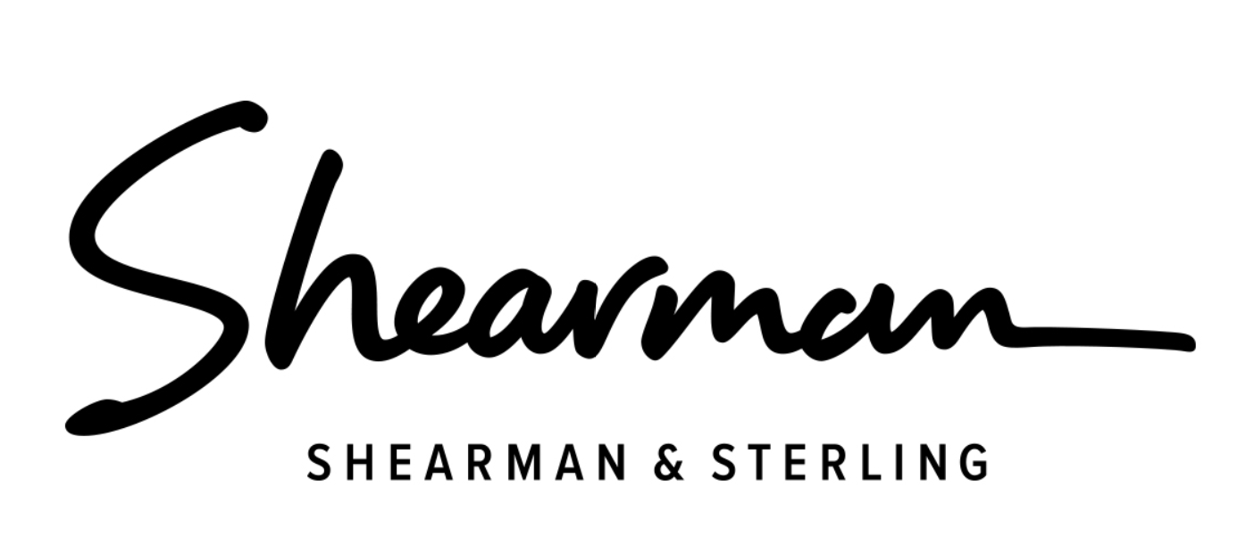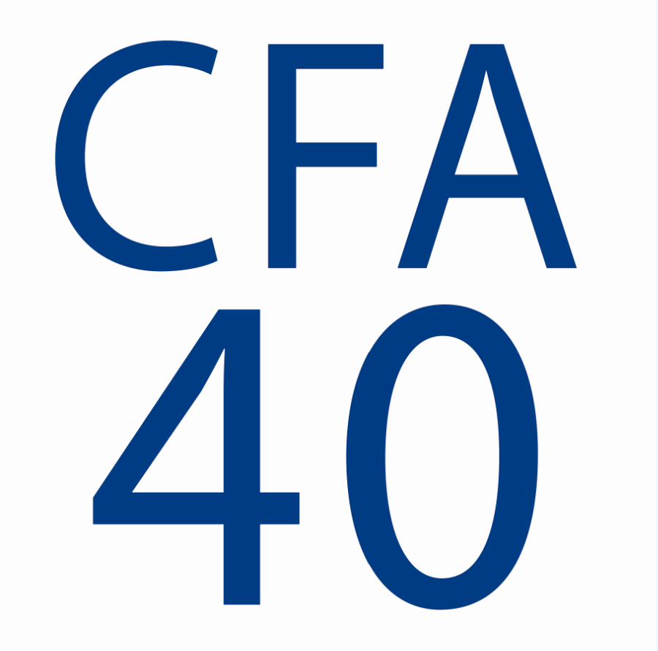  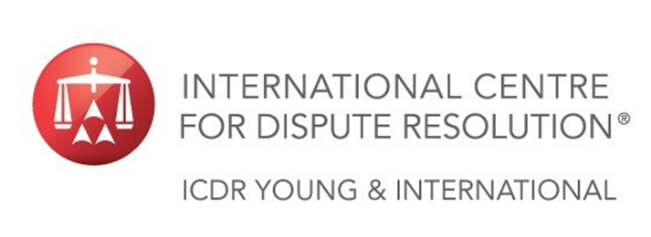
About YCAP
YCAP was launched by a group of young Canadian arbitration practitioners in 2004. The mission of YCAP is as follows:
- to promote interest in and understanding of international arbitration, particularly in Canada, among young lawyers working in private practice and with corporations and government, as well as among other interested young professionals;
- to provide professional development opportunities and a forum for the exchange of ideas for young lawyers and other young professionals with an interest in international arbitration; and
- to provide professional networking opportunities for young lawyers and other young professionals with an interest in international arbitration.

Registration for the YCAP 2019 Spring Symposium
In order to register for the YCAP 2019 Spring Symposium, please register at:
https://fr.xing-events.com/PAW2019-YCAP.html
Please note that there is no registration fee or other charge for this event.

Questions or Further Information
If you have any questions or require any further information regarding the YCAP 2019 Spring Symposium, please email Christina Doria at Christina.Doria@bakermckenzie.com, adding “YCAP 2019 Spring Symposium Registration” in the subject line.

With the compliments of the YCAP Board of Directors

